Tabular CARD Frequently Asked Questions
March 29, 2019

Q. Does the CARD contain dollar values?
A. The CARD is not intended to contain estimates, and therefore, should contain very few dollar values, if any. However, there is pricing data for components on the Parts and LRU tables as well as some COTS Software license pricing on the Software Dev table. Estimating methodologies and resulting estimates (e.g., POE) should not be included in the CARD. The CARD succinctly describes the key technical, programmatic, operational, and sustainment characteristics of a program and provides all of the program information necessary to develop a cost estimate.
Information Necessary to Develop a Cost Estimate | CARD Table
Size weight and power by WBS element for use as cost drivers for CERs, scaling, or analogy selection. | SWAP
Design heritage by WBS element for use in estimating nonrecurring costs via CERs, scaling, or analogy selection. | Heritage
Unique physical, performance, and configuration parameters for use as cost drivers for CERs, scaling, or analogy selection. | PMP Technical
Common element metrics and cost drivers to enable direct parametric estimation in lieu of factoring their cost off of PMP cost. | Nonhardware Technical
Facility construction and conversion data for use in estimating facility costs. | Construction
Metrics and cost drivers to estimate the cost of maintenance and other O&S costs. | O&S
Software parameters necessary for estimating software development cost and software maintenance cost. | Software Dev  Software Mx
Quantity by year for phasing the estimate and performing learning curve calculations. Cumulative fielding quantity for O&S cost calculations. | Quantities and O&S Time Phased
For multiple end-item configurations, identify end item composition (both uniqueness and commonality) | Configuration
Operators, Maintainers, and Support personnel by grade and year to estimate manpower costs. | Manpower Time Phased
Program SEPM personnel by grade and year to estimate Government program office manpower. | Manpower Time Phased
Logistics parameters regarding removables | LRU
Parameters by part for performing COTS-heavy catalog or bottom-up estimating or component analysis. | Parts
Information to identify GFE items and to calculate contract loads by vendor tier. | Parts
Information necessary to identify items that will not be part of contractor's cost. | Roles
General system knowledge needed to select the estimating WBS and to select analogies. | Program
Dates to time-phase and inflate a cost estimate. Durations to estimate time-sensitive costs. | Milestones
Phase and Contract (Production Lots) begin/end dates needed to estimate time-sensitive costs. Contract information necessary to link to other contract-based reporting. Lot information needed to perform learning curves. | Contract

Q. How much of the tabular data should be included (vice referenced) in the narrative CARD?
A. While duplicating content from the tabular CARD is not required, minimal duplication of content may help reviewers expedite approval of the narrative CARD as a stand-alone document. Duplicate content should be limited to those tables where the particular data supports the text in the narrative and is not too detailed. Some data (e.g., part numbers, vendor names, individual component tech parameters) would add unnecessary detail to the narrative CARD. Repeating content does add to the burden of maintaining the duplicate content across the two documents. Each program will need to decide what level of referencing is appropriate given the program’s review chain-of-command and nature of the program.

Q: What if my program doesn’t have enough data to populate the Parts table?
A: For those programs that have a Bill of Material (BOM), it should be included in the Parts table. For those programs without a BOM, place the parts information you have available in the Parts table and note the fact that a BOM does not exist.

Q. There appears to be redundancies within the CARD tables. For example, there appear to be multiple places to input data for COTS Software licenses. Where should I input data on COTS Software licenses?
A. The tables are purposefully constructed to accommodate a wide range of programs at any point in a life cycle. As such, some data items appear in more than one location. Any given item of information need only be entered in one location. There are occasions, though, where a table may need to be completely stand-alone (say for coordination, buy-in, and approval within a program office) which would require some data to be entered more than once.
There are three places that enable the entry of data related to software licenses: 1. the Software Dev table; 2. the Software Maintenance table; and 3. the O&S table. Since these tables are designed to be stand-alone, it is useful for reviewers as well as analysts outside the program to view COTS software info in all three places. It is considered best practice to pick a single table (e.g., the Software Dev table) to enter the latest inputs and link the other tables to it. There are, however, unique fields on each table that must be input separately.
The tables may also have slightly different content or information. The software development table may include “development” licenses associated with building the software product. It is possible that some development licenses may be required for software maintenance. The maintenance table may also include information about which products have maintenance licenses, a periodic cost associated with getting maintenance fixes and upgrades to COTS products used in the baseline; this information may potentially be identified as the percentage of the “full” license cost. Tables associated with O&S may include “run-time” licenses or licenses associated with how many servers or users are operating the system.

Q. Is the manpower time phased table designed to capture staffing for all personnel?
A. It is suitable for expressing any type of annual head-count.
For the investment phase (development and production), FTEs for PMO personnel and non-prime contractor personnel (e.g., FFRDC, A&AS systems engineering, Government/Military) should be input on the Manpower Time Phased table.
While rows for prime contractor personnel are not part of the pre-defined rows, rows may be inserted for prime contractor FTEs if either the CAPE, SCA, or program office deems it useful to do so.
For the Operations and Support phase, the manpower table should include staffing associated with both operations personnel (e.g., the military and civilian personnel operating the data center you just fielded) as well as staffing associated with activities like software maintenance performed by a Government depot.
Furthermore, the notes column is useful to explain labor categories (e.g., NH3, E-5) as well as the appropriations (e.g., 3600, 3400) associated with each row.

Q. Does the CARD differentiate between estimated and actual parameter values?
A. Yes. Most input values are accompanied by a column prompting the user to select “estimate” or “actual”. Along with the Source column, this information clearly conveys the pedigree of the input. The goal is for late life-cycle CARD submissions to include mostly “actuals”. The Notes column is available to further describe the value pedigree is needed.

Q. What is the difference between the Production, Deliveries, and Fielded Density rows on the Quantities and O&S Time Phased table?
A. The Production rows denote the quantities in the years they were ordered. The notes column can be used to specify the fiscal year of the funds which were used to purchase those quantities since many order dates include funds from multiple fiscal years. The Deliveries rows denote the year the contractor delivers the end-item to the customer organization. The Fielded Density rows are cumulative values representing the inventory of supported end items. However, there may be a lag between the delivery year and the fielding year if additional time is required to install or initialize the end-item for operation.

Q. Does every row need an entry in the Source and Notes columns?
A. While it is important to identify the source for every input, an input in the notes column is not always necessary. Notes are frequently required to supplement or clarify the information in an input. In other words, the notes inputs are designed to further amplify or clarify row contents. For example, the notes column is a good place to clarify the confidence levels for a parameter’s value. Another example is noting additional definition for a withhold rate.

Q. How do the quantities and configuration tables inter-relate?
A. The quantities table reports how many of each kind of end item (in rows) will be purchased, delivered, and fielded per year (in columns). This is typically for the primary end items (top-level WBS elements). The configuration table provides a matrix showing quantities of components (in rows) per full end items (in columns) of various configurations. The rows (containing the various configurations) on the quantities table become the columns in the configuration table.
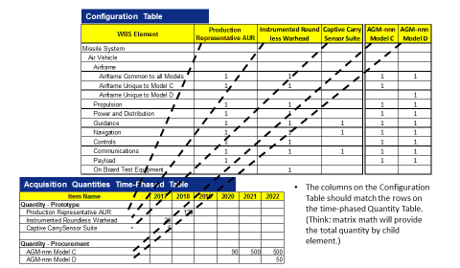
Between the total quantities as well as the number of components needed per system quantity, the analyst can see the ultimate end-item quantity and the associated WBS elements. However, most cost estimates need at least one level of detail below the WBS element and the next FAQ addresses this need.

Q. How do the configuration and LRU tables inter-relate?
A. Once the high-level quantities by year and configuration of WBS elements by end-item type are known, the next level of data is presented on the LRU table. The LRU table shows a mapping between WBS elements and LRU data. LRU level data includes unit price, mean time between unscheduled removals (MTBUR), etc. Most bottoms-up O&S estimates are completed at the LRU level. It is important to know how the LRUs trace back to the WBS elements so cost can be reported against the correct WBS element. However, it is important to note that not all WBS elements have associate LRUs (e.g., SE/PM, training, test).

Q: How do the LRU and Parts tables inter-relate?
A: The Parts table will typically be used for select WBS elements that are largely COTS or catalogue-like information. The parts table references the WBS number but does not reference the associated LRU. Since estimates are done either at the LRU level or the piece-parts level, it is not necessary to show the interrelationship between the LRUs and parts. 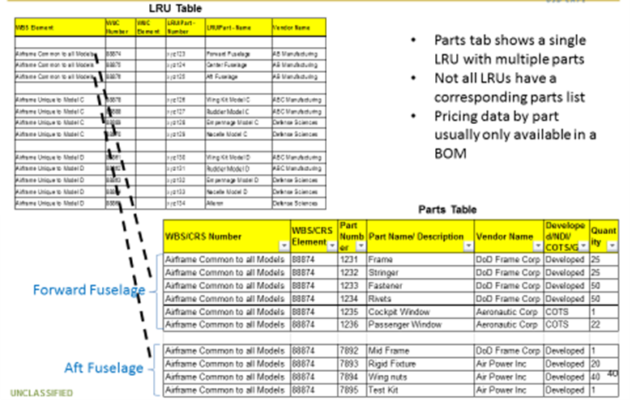

Q. What if the updated input value is different from a previous CARD submittal?
A. Each CARD submission stands alone. The tabular CARD does not accommodate tracking between submissions. However, the structured nature of the CARD tables will allow values over time to be aligned and changing values over time are expected. The changes over time by WBS element and parameter provide key insights for future, analogous programs.

Q. Are the tabular CARD and the Tech Data Report (TDR) essentially the same thing?
A. No. The CARD is a program office product whereas the TDR is a product from a contractor. The CARD’s PMP Hardware Technical table is purposefully similar to the Tech Data Report and enables a program to readily obtain their CARD information from the contractor should they chose to do so.

Q. Is the CARD exclusively to be used for estimating or is it designed to be an archival document?
A. Policy states both are goals for the CARD.

Q. Is the tabular CARD mandatory?
A. Acquisition Category (ACAT) I programs approaching milestone decisions after September 1, 2017, must follow the format specified in the guidelines found at https://cade.osd.mil/policy/card.

Q. How often is the CARD updated?
A. Policy stipulates that CARDs are updated at least annually as part of the annual POM process to support Budget Estimates, Program Office Estimate (POE) updates as well as Independent Cost Estimates (ICE).

Q. Are there CARD waivers?
A. Yes, and all waivers are approved by OSD CAPE.

Q. Is there a way to track changes between multiple CARD submissions?
No, each submission should stand alone. The structured nature of the tables should enable straightforward comparison of successive submissions. However, a program may add a “change-track” sheet if they wish.

Q. Can a program insert additional sheets for information not accommodated in the existing tables?
A. Yes. While the tables are constructed to accommodate a wide range of program types, unforeseen information needs may arise. Information that provides added value to cost estimates should be included via additional sheets or added rows in existing sheets.

Q. If any part of my CARD is classified, how do I transmit it to the CAPE?
A. Contact your CAPE analyst for the proper transmittal method.

If these FAQs do not answer your question and you have reviewed the CARD Training presentation and the “Guidelines for the Preparation and Maintenance of CARD Tables” found on the CARD website (https://cade.osd.mil/policy/card), please contact your CAPE analyst with your question.

